

*School in Movement: enjoying wealth being in good health*

**Project Number: 2014-1-ES01-KA201-003518_4**

***1st Chess Newsletter***

In December 2014 the two teachers in charge of the Project, Severi Giancarla and Roberta Gandini, organized a **Chess Laboratory** for the students taking part to the *Erasmus Plus Project “ School in Movement: enjoying wealth being in good Health”.* It was also opened to whoever in our big school “ Liceo A.Volta-F.Fellini” was interested in this special sport and lots of students decided to join in. It started on 5th December 2014 and went on till 28th May 2015 with the final on line tournament where all the partner schools took part with their players. Between December and January all the participants registered in the international site Chess.com and we founded a Chess Club in our school.

The **Chess Course** lasted for all the school year 2014/15 and ended with the **international on line tournament on 28th May 2015**. The aim of the course was that of **1.** teaching the basics of Chess playing for the students who had never played it and **2.** reinforcing the knowledge about the different strategies and techniques of this sport for those who had already played it. The project offered the possibility for the students to

* *learn and practice strategies in chess playing.*
* *find new and interesting ways to spend their free time.*
* *meet other students with the same interests.*
* *develop creativity, prediction, planning ahead, imagination, intuition.*
* *develop decision making, self control, slow and thoughtful action.*
* *improve attention, concentration, patience, logic skills, organizational skills, intellectual abilities, cognitive thinking.*
* *promote competition and competitive behavior from the intellectual point of view.*

The **methodology** consisted of a series of face to face lessons with subsequent discussion and practice. All the activities and sessions of the chess course were monitored by Prof. Brancaleoni Maurizio and his assistants. The equipment was provided by his team of instructors and was made of chessboards for the participants with chess checkers and timers and a big magnetic chessboard with checkers used by the teacher when he showed the tactics and possible moves.

One of our students, Alessandra Masini, played in the international chess tournament that was held in March 2015 in Spain, Talayuela.

***2nd Chess Newsletter***

After the summer 2015 our students went on playing chess on the Chess.com site, which led to the **second** stage of the **international tournament on 17th** **December 2015**. Our student involved in the game was Edfi Omar from class 4th Ds who started playing at 11:30 a.m. Winner of this part of the game was a Turkish student. **On 17th March 2016** another student of the Erasmus Plus Project, Luca Crescentini from class 4th As, played from 11:30 to 13:00 at school and then went on for a few days until the end of this 3rd stage of the game. The same student, Luca Crescentini, took part in the chess international tournament that was held in Latvia on 24th May in Liepaja, he got second. **Well done Luca!** The other girl Masini Alessandra from class 4th Es played in the same tournament and did well, too.

*Edited by Luca Crescentini*

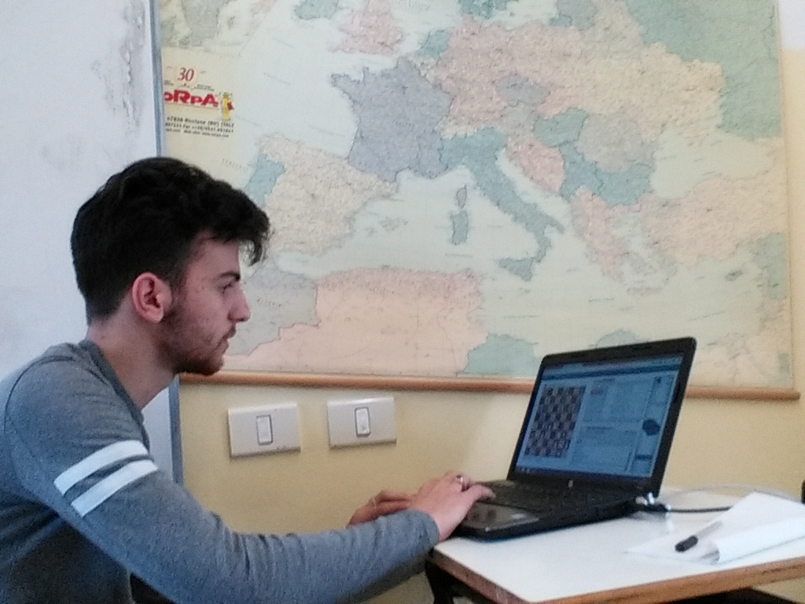



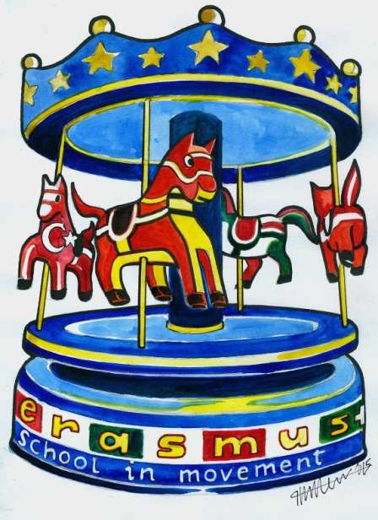

*School in Movement: enjoying wealth being in good health*

2014-1-ES01-KA201-003518_4