

***SCHOOL IN MOVEMENT: ENJOYING WEALTH BEING IN GOOD HEALTH***

Project Number: 2014-1-ES01-KA201-003518_4

**Newsletter of the 6th online tournament**

On 4th April 2017 the last online chess tournament started in Italy, Riccione, in our school Liceo A.Volta-F.Fellini.

The game was a bit delayed so in the meanwhile we got some pictures of our candidates, first of all of Luca Crescentini, our “champion”, or at least the one who won all the Italian tournaments we’ve played up to now.

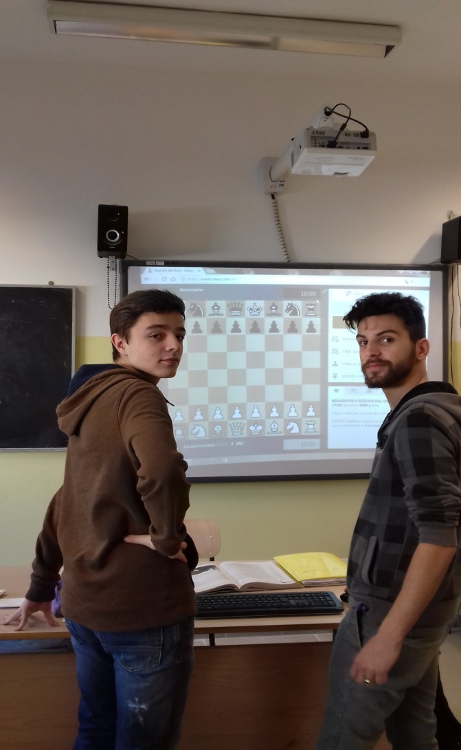

*Ready? Steady? Go!!*

*Luca and Dima are ready to start!*

*They’re looking forward to thrashing all the other competitors….*

The tournament lasted longer than expected because six games had to be completed in order to win. Luca went on playing and day by day he won all the matches ending up first.

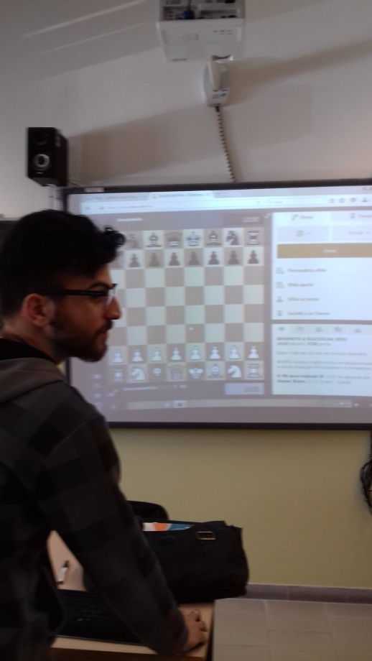 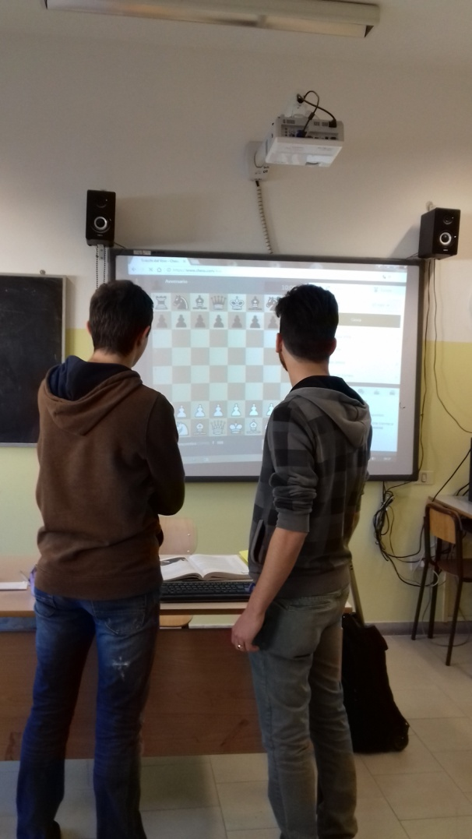

This is the class where the tournament started. Luca has always played in the international online games of the last three years but this is the first time he has come first. He will be playing also in the last tournament that will be held on 9th May in Italy. We hope that Mr. Brancaleoni will come to supervise the set of games and help us organize this event during the Meeting in Italy with all our Partners.

Our students have gone on playing chess in these 3 years of Erasmus + Project and have appreciated the long Chess Course that Mr. Brancaleoni and his team of experts led all through the school year in our school. Luca’s classmates had all taken part in this course.

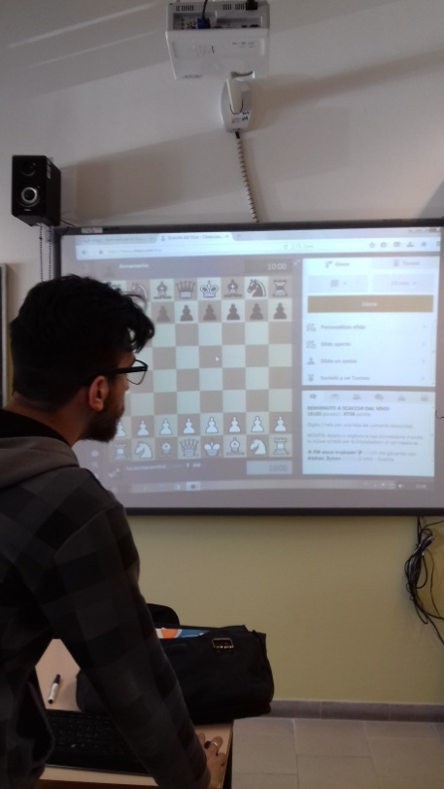In May 2017 around 11 chess players from Spain, Turkey, Latvia and Italy will compete in an alive tournament.

Luca has refined his skills during the time of the Project, coming second in the last tournaments. This year he has to take his final State Exam before going to University, he’s certainly one of the most brilliant minds of our school. We wish him good luck for the next chess competition.

Well done, Luca!

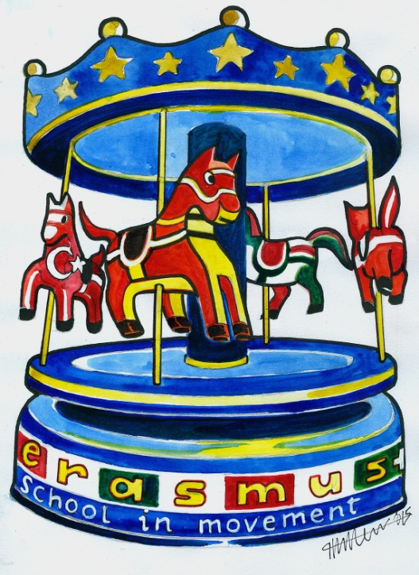 *Edited by 5thAs*